**LAB REPORT – 5**

**Title:** Building a seven-segment display decoder, as well as learn to use Altera Quartus to enter a schematic to implement the logic for a seven-segment decoder and ModelSim to simulate.

**Purpose:**

* The purpose of thus lab is to design, simulate and implement a seven-segment display.
* Downloading the code onto DE2 Board and analyze the output of the given inputs.

**Requirements:**

* Altera Quartus II 9.1p2 software
* DE2 board

**Description:**

**Altera Quartus II 9.1p2 –** It’s a wed edition software which allow the user to analyze and synthesize the HDL designs, which enables the user to design the schematic model and simulate the design. Quartus implement the VHDL and Verilog for hardware description, vector waveform simulation and visual editing of logic circuits.

**DE2 board:** It’s a board to test the circuit design on FPGA chip. FPGA will correspond to the input and outputs of the design.

**Seven-Segment Decoder**

7-segment **LED** (Light Emitting Diode) or **LCD** (Liquid Crystal Display) type displays, provide a very convenient way of displaying information or digital data in the form of numbers, letters or even alpha-numerical characters.

Typically, seven-segment consist of seven individual colored LED’s (called the segments), within one single display package. In order to produce the required numbers or HEX characters from 0 to 9 and A to F respectively.

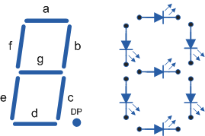

|  |  |  |  |  |  |  |  |  |  |  |  |  |
| --- | --- | --- | --- | --- | --- | --- | --- | --- | --- | --- | --- | --- |
| Hexadecimal  Digit | D3 | D2 | D1 | D0 | Sg | Sf | Se | Sd | Sc | Sb | Sa | (in hex) |
| 0 | **0** | **0** | **0** | **0** | **1** | **0** | **0** | **0** | **0** | **0** | **0** | **40** |
| 1 | **0** | **0** | **0** | **1** | **1** | **1** | **1** | **1** | **0** | **0** | **1** | **79** |
| 2 | **0** | **0** | **1** | **0** | **0** | **1** | **0** | **0** | **1** | **0** | **0** | **24** |
| 3 | **0** | **0** | **1** | **1** | **0** | **1** | **1** | **0** | **0** | **0** | **0** | **30** |
| 4 | **0** | **1** | **0** | **0** | **0** | **0** | **1** | **1** | **0** | **0** | **1** | **19** |
| 5 | **0** | **1** | **0** | **1** | **0** | **0** | **1** | **0** | **0** | **1** | **0** | **12** |
| 6 | **0** | **1** | **1** | **0** | **0** | **0** | **0** | **0** | **0** | **1** | **0** | **02** |
| 7 | **0** | **1** | **1** | **1** | **1** | **1** | **1** | **1** | **0** | **0** | **0** | **78** |
| 8 | **1** | **0** | **0** | **0** | **0** | **0** | **0** | **0** | **0** | **0** | **0** | **00** |
| 9 | **1** | **0** | **0** | **1** | **0** | **0** | **1** | **1** | **0** | **0** | **0** | **18** |
| A | **1** | **0** | **1** | **0** | **0** | **0** | **0** | **1** | **0** | **0** | **0** | **08** |
| B | **1** | **0** | **1** | **1** | **0** | **0** | **0** | **0** | **0** | **1** | **1** | **03** |
| C | **1** | **1** | **0** | **0** | **0** | **1** | **0** | **0** | **1** | **1** | **1** | **27** |
| D | **1** | **1** | **0** | **1** | **0** | **1** | **0** | **0** | **0** | **0** | **1** | **21** |
| E | **1** | **1** | **1** | **0** | **0** | **0** | **0** | **0** | **1** | **1** | **0** | **06** |
| F | **1** | **1** | **1** | **1** | **0** | **0** | **0** | **1** | **1** | **1** | **0** | **0E** |

**Schematic Design**

After working for more than 2 hours in lab we developed the schematic design using Altera Quartus II,simulated the design using ModelSim and implemented the design on hardware named DE2 board.

**Step 1:** Creating a new schematic, click **File/New/VHDL,** after the windows opens click on the Templates icon and choose **VHDL/Full Designs /Arithmetic /Adders / Signed Adder.** Then copy and paste the code it shows into the edit window. Then, edited the entity declaration to “**Sevensegment**”eliminate one of the inputs, and turn the other one into a four-bit input array of STD_LOGIC named SW.

**Step 2:**  Similarly, name the output HEX0(6 down to 0); it will be STD_LOGIC. Remove the SignedAdder and generic declaration.

**Step 3:**  Writing the code and saved it with name Sevensegment. which will look like:

entity Sevensegment is

port

(

SW : in std_logic_vector (3 downto 0);

Hex0: out std_logic_vector (6 downto 0)

);

end entity;

architecture rtl of Sevensegment is

begin

process(SW)

begin

case(SW) is

when"0000" => Hex0 <= "1000000";

when"0001" => Hex0 <= "1111001";

when"0010" => Hex0 <= "0100100";

when"0011" => Hex0 <= "0110000";

when"0100" => Hex0 <= "0011001";

when"0101" => Hex0 <= "0010010";

when"0110" => Hex0 <= "0000010";

when"0111" => Hex0 <= "1111000";

when"1000" => Hex0 <= "0000000";

when"1001" => Hex0 <= "0011000";

when"1010" => Hex0 <= "0001000";

when"1011" => Hex0 <= "0000011";

when"1100" => Hex0 <= "0100111";

when"1101" => Hex0 <= "0100001";

when"1110" => Hex0 <= "0000110";

when"1111" => Hex0 <= "0001110";

when others => Hex0 <="0000000";

end case;

end process;

end rtl;

**Step 4:** Compile the given code and then simulate it using ModelSim.

**Simulation**

After designing the schematic model of seven segment we simulate the design in HDL such as Verilog HDL using ModelSim simulator. Following are the steps followed to simulate the design:

**Step 1:** We simulate the design using ModelSim. ModelSim expects a description of a circuit in a hardware description language (HDL) such as Verilog. To convert our schematic to Verilog, we opened the schematic and chose File - Create / Update, Create HDL Design File for Current File. Chose Verilog HDL.

**Step 2:** Now fire up ModelSim SE 10.1b from the Tools, Run Simulation Tool pulldown. We got a message indicating that there was no path to ModelSim. To correct this problem, we chose **Tools / Options /EDA tool options / Paths** and specified the path for ModelSim-Altera as **C:/Program Files/Altera/13sp1/modelsim_ase/Win32aloem**. Then recompiled (**Processing / Start Compilation**) and start up ModelSim with **Tools / Run Simulation Tool / Gate-Level Simulation**.

**Step 3:** Chose **Compile / Compile All** to compile the Verilog code into a form that ModelSim can simulate. Watch for and correct errors in the transcript pane. Then chose **Simulate / Start Simulation**.

**Step 4:** When the simulator starts, ModelSim will open more panes including sim and Objects that help us select signals for the waveform viewer. In the objects window, we’ll see all the inputs, outputs, and internal wires. Shift-click to select them all. Then right-click and choose Add to Wave, Selected Signals. A Wave pane will pop up with the signals.

**Step 5:** To add the wave position, right-click on the names in the object pane and choose Add to wave. Finally, we apply the inputs. In the transcript pane at the bottom, type

Force sim: /Sevensegment/D3

Force sim: /Sevensegment/D2

Force sim: /Sevensegment/D1

Force sim: /Sevensegment/D0

**Step 6:** We continued with the sixteen other patterns of inputs to check our truth table.

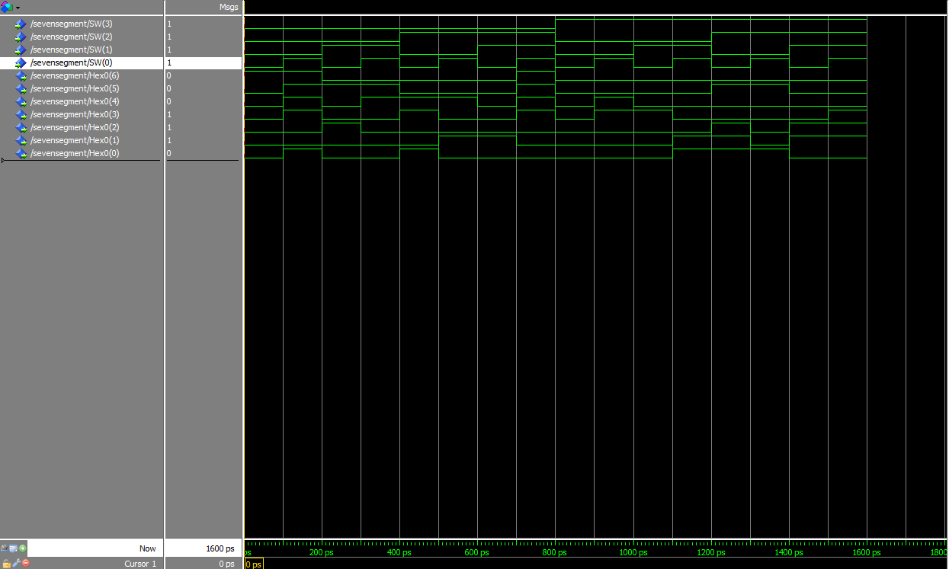

**Fig. 1 Simulation Waveform Diagram**

**DE2 Board Implementation:**

After the design is simulated using ModelSim correctly, we close the ModelSim. Our next goal was to download the circuit onto a DE2 test board to test it on the FPGA chip. The pins on the FPGA will correspond to the inputs and outputs of our design. We need to assign the pins so that we can use switches to control the inputs and LEDs to display the outputs.

**Connecting the DE2 board:**

* We plugged in the power adapter, attached it to the board
* Connected the DE2 board to the computer USB cable port. The cable must go into the leftmost USB jack on the board labeled BLASTER
* Switch S9 should be in the run position

**Testing the DE2 Board:**

* Toggle the Switch SW [0], SW [1], SW [2], SW [3] to different sixteen input patterns
* Check the output in HEX0.
* For every combination of the inputs the HEX0 will glow and display the output.

**Our design worked correctly on the DE2 Board and showed the desired output. Below is the output of the seven segment decoder on DE2 Board.**

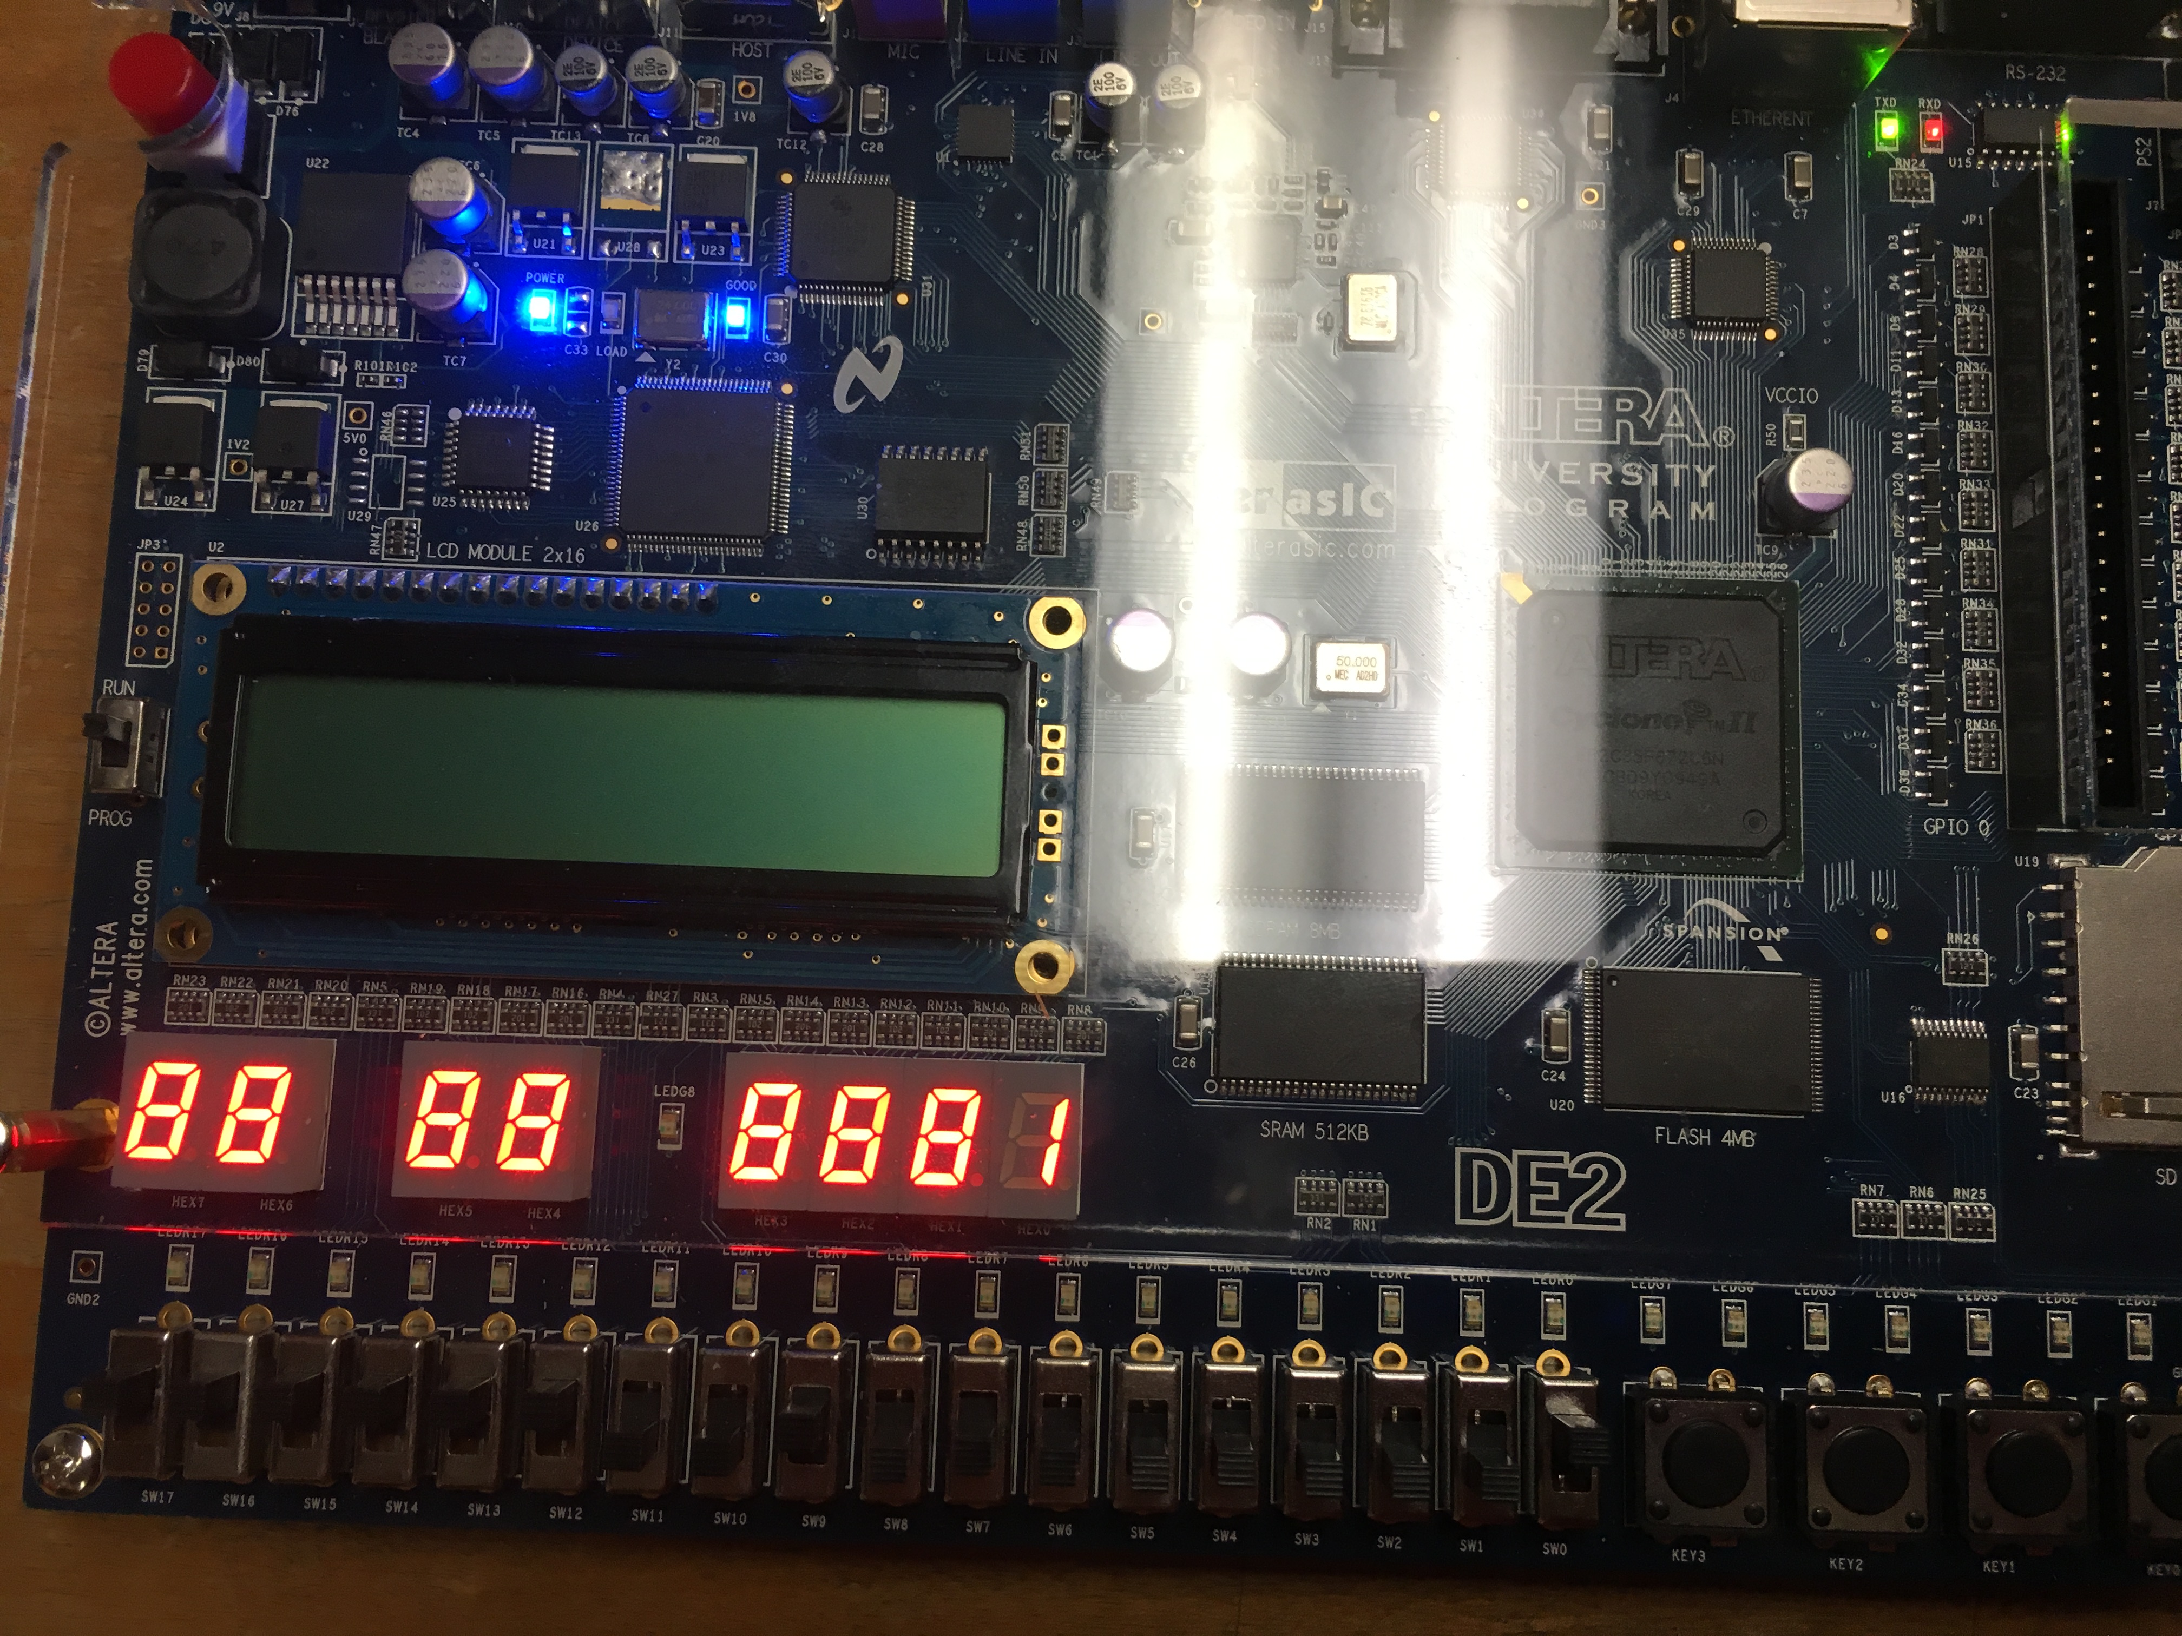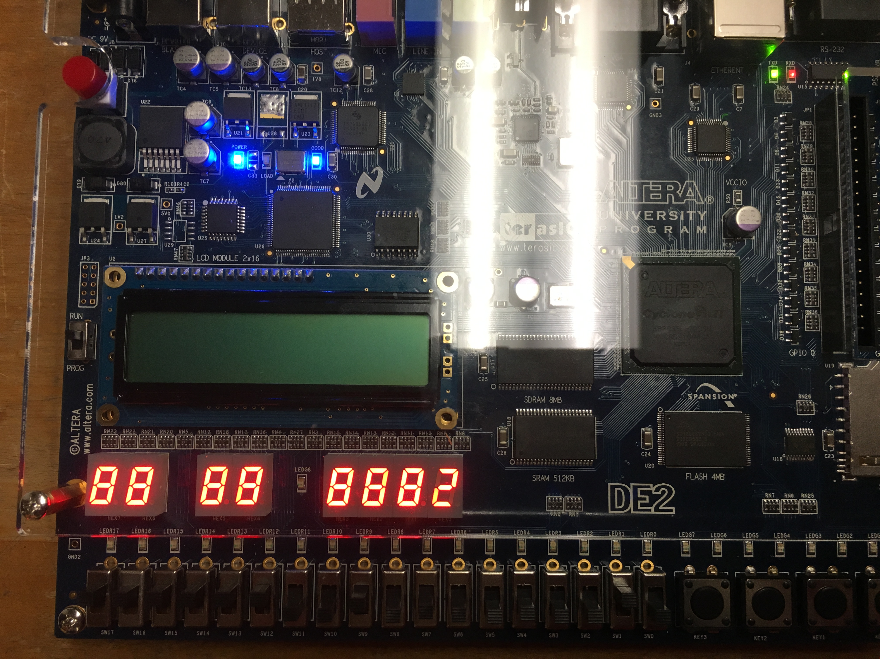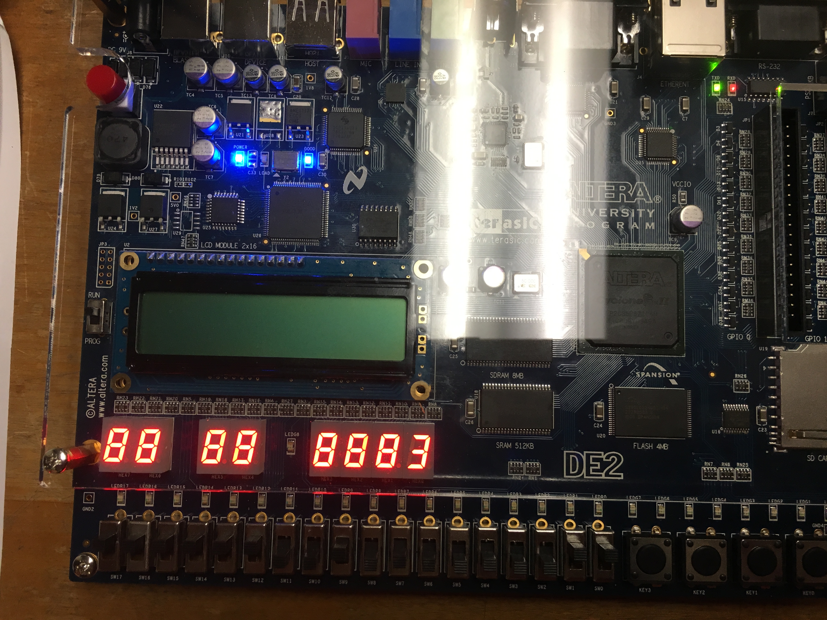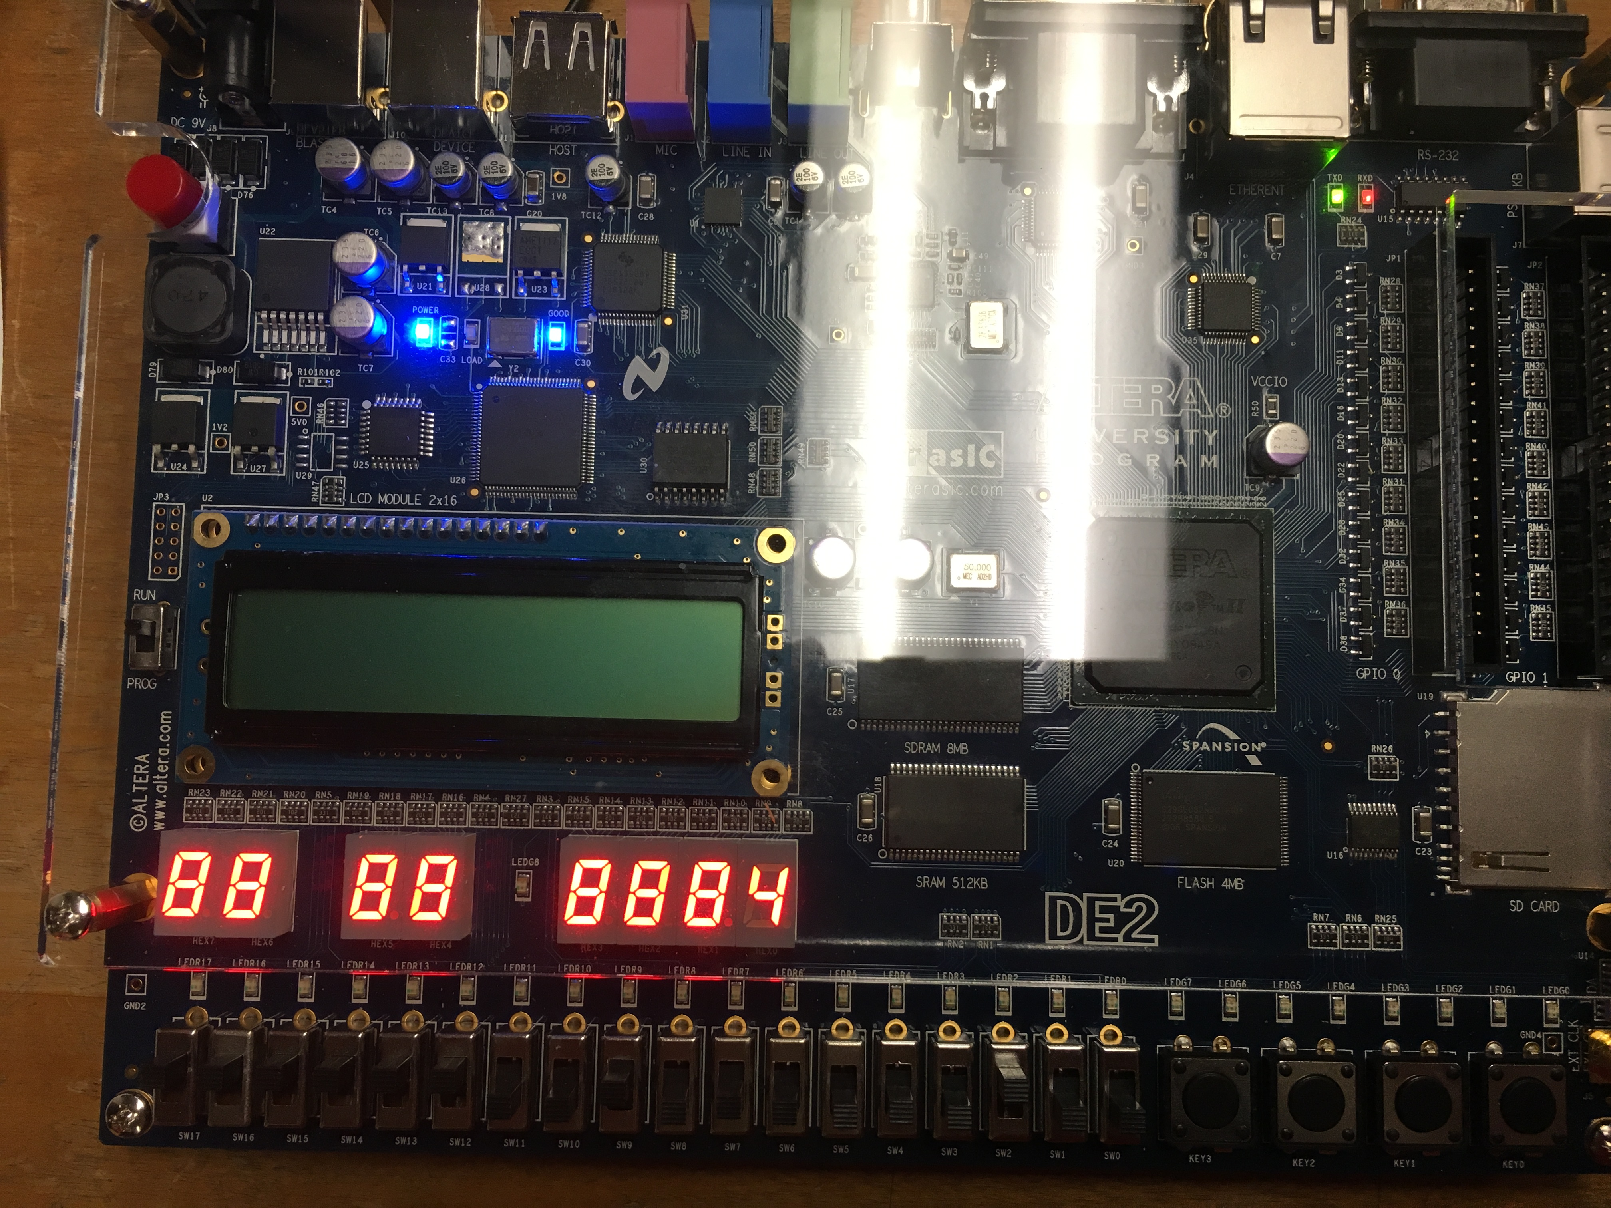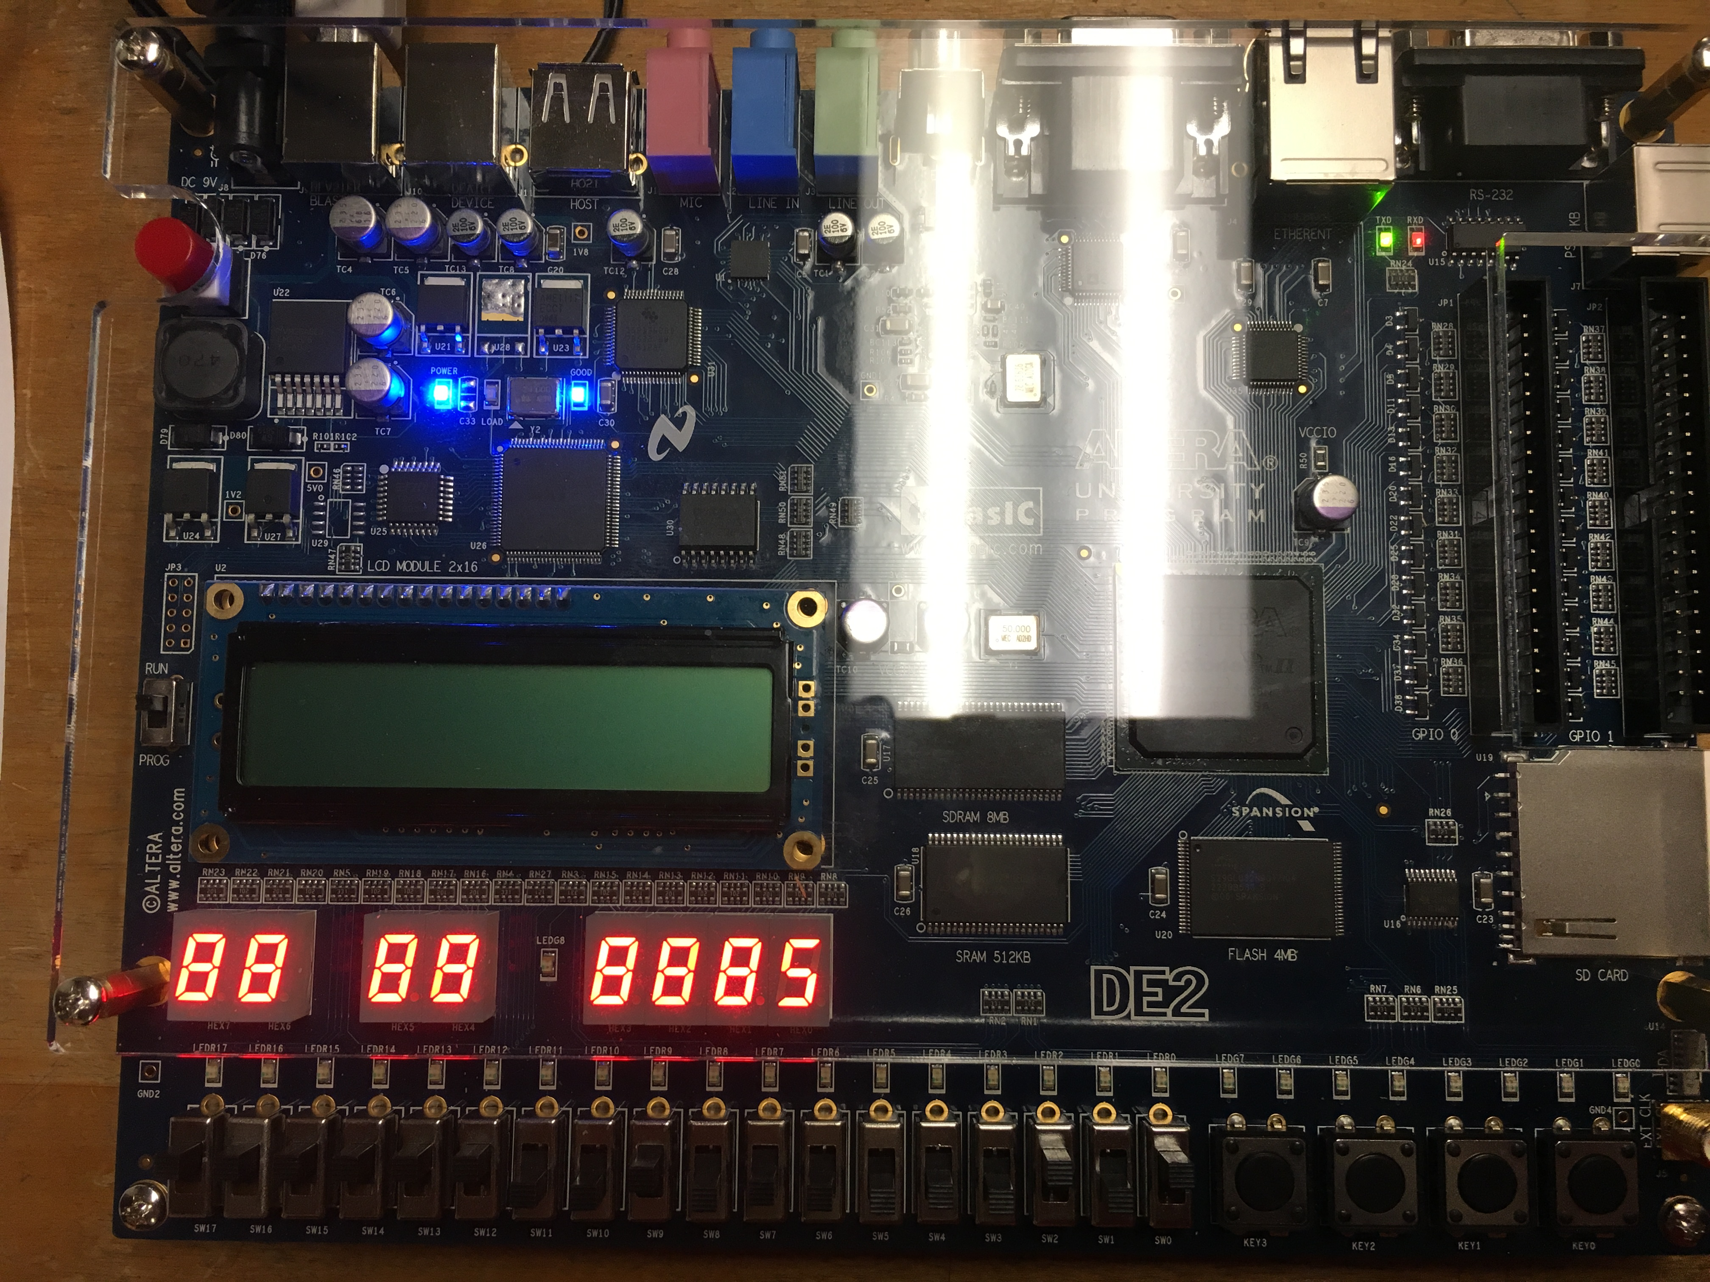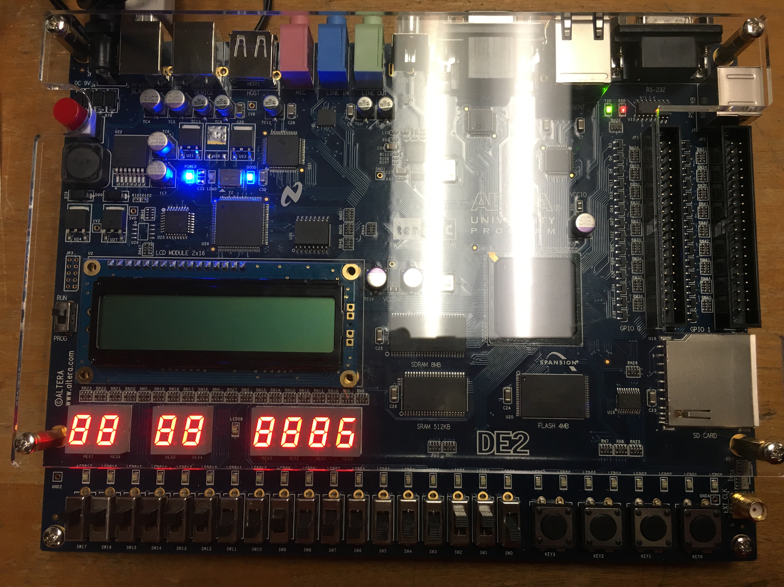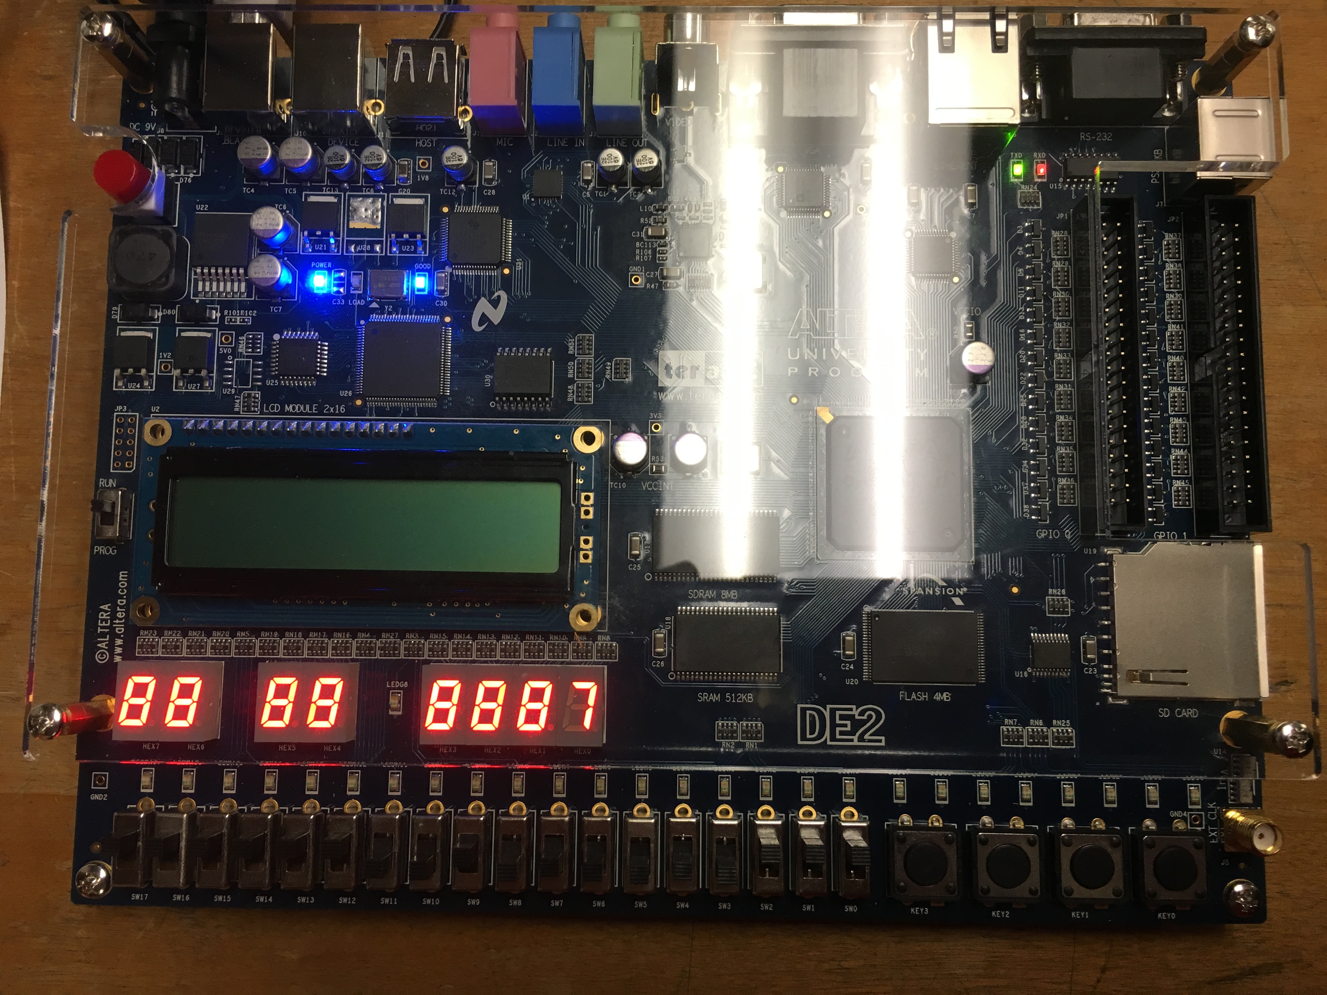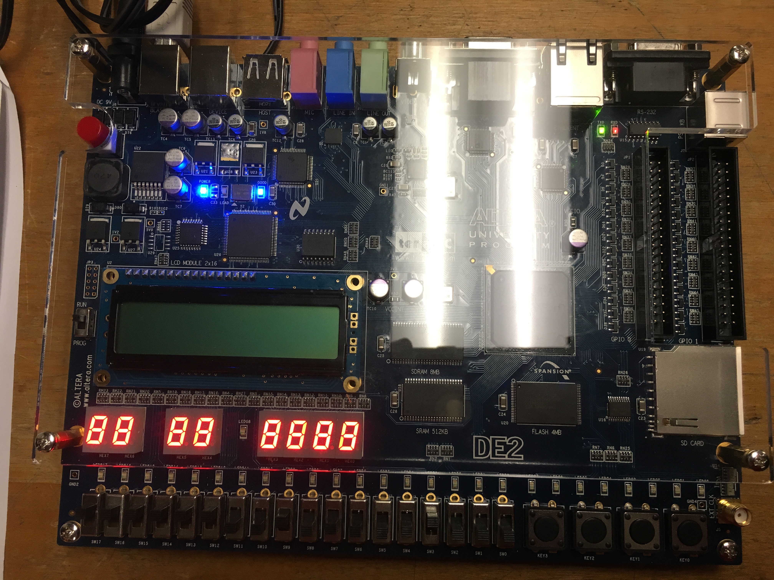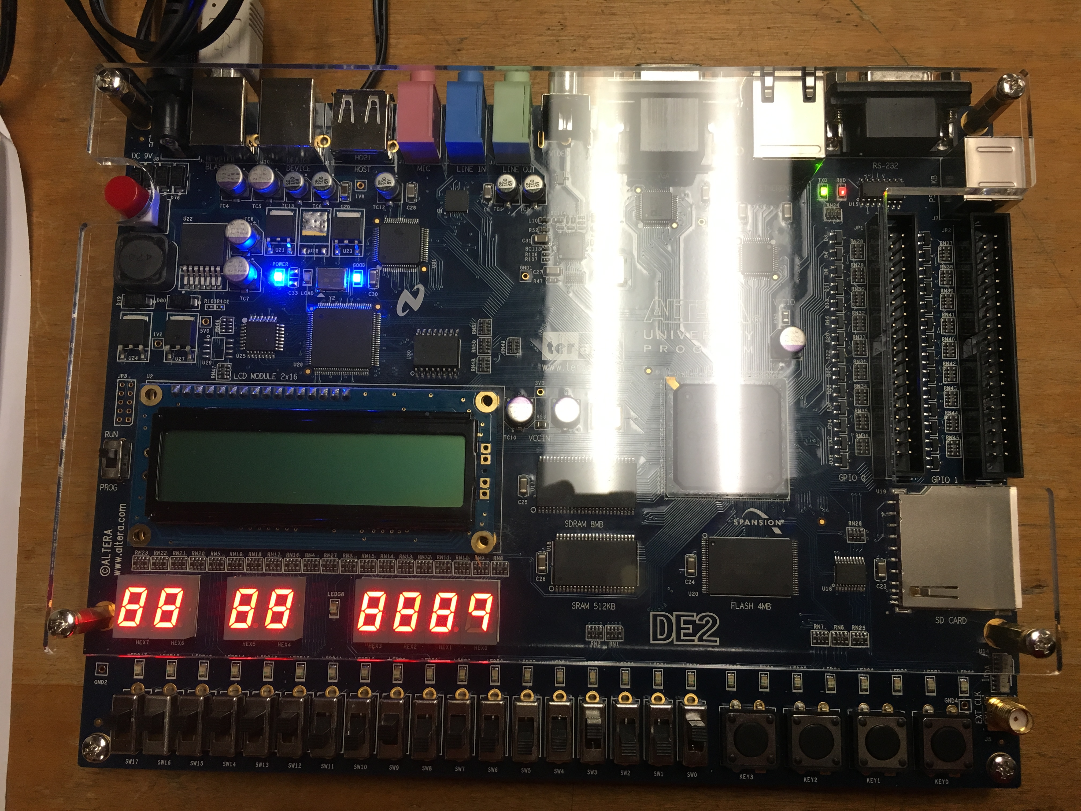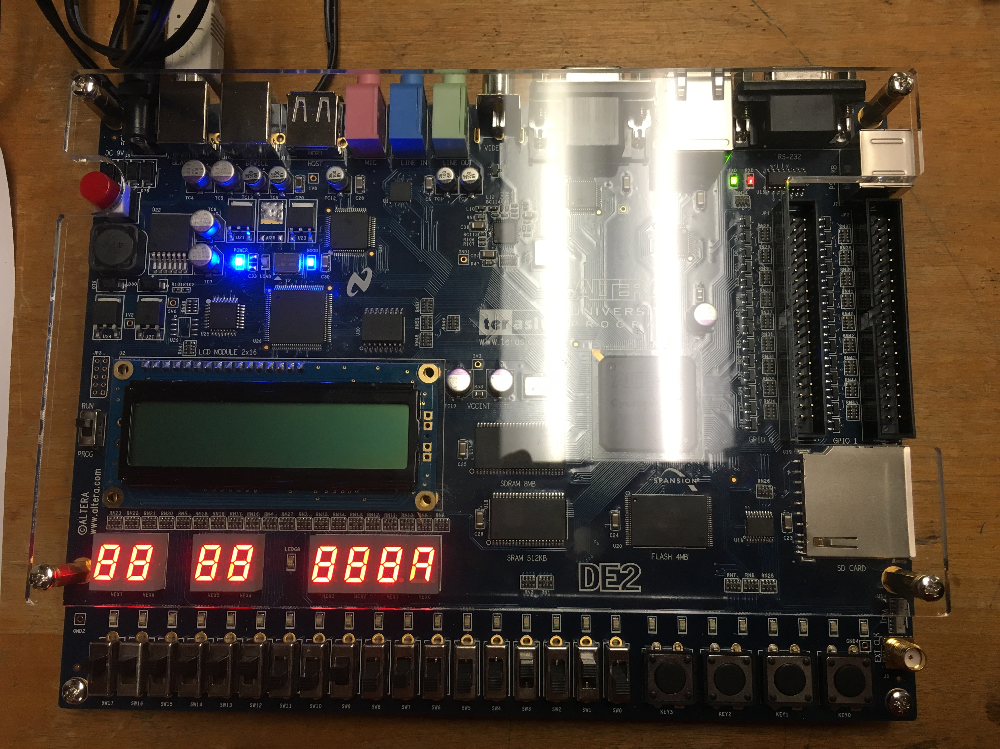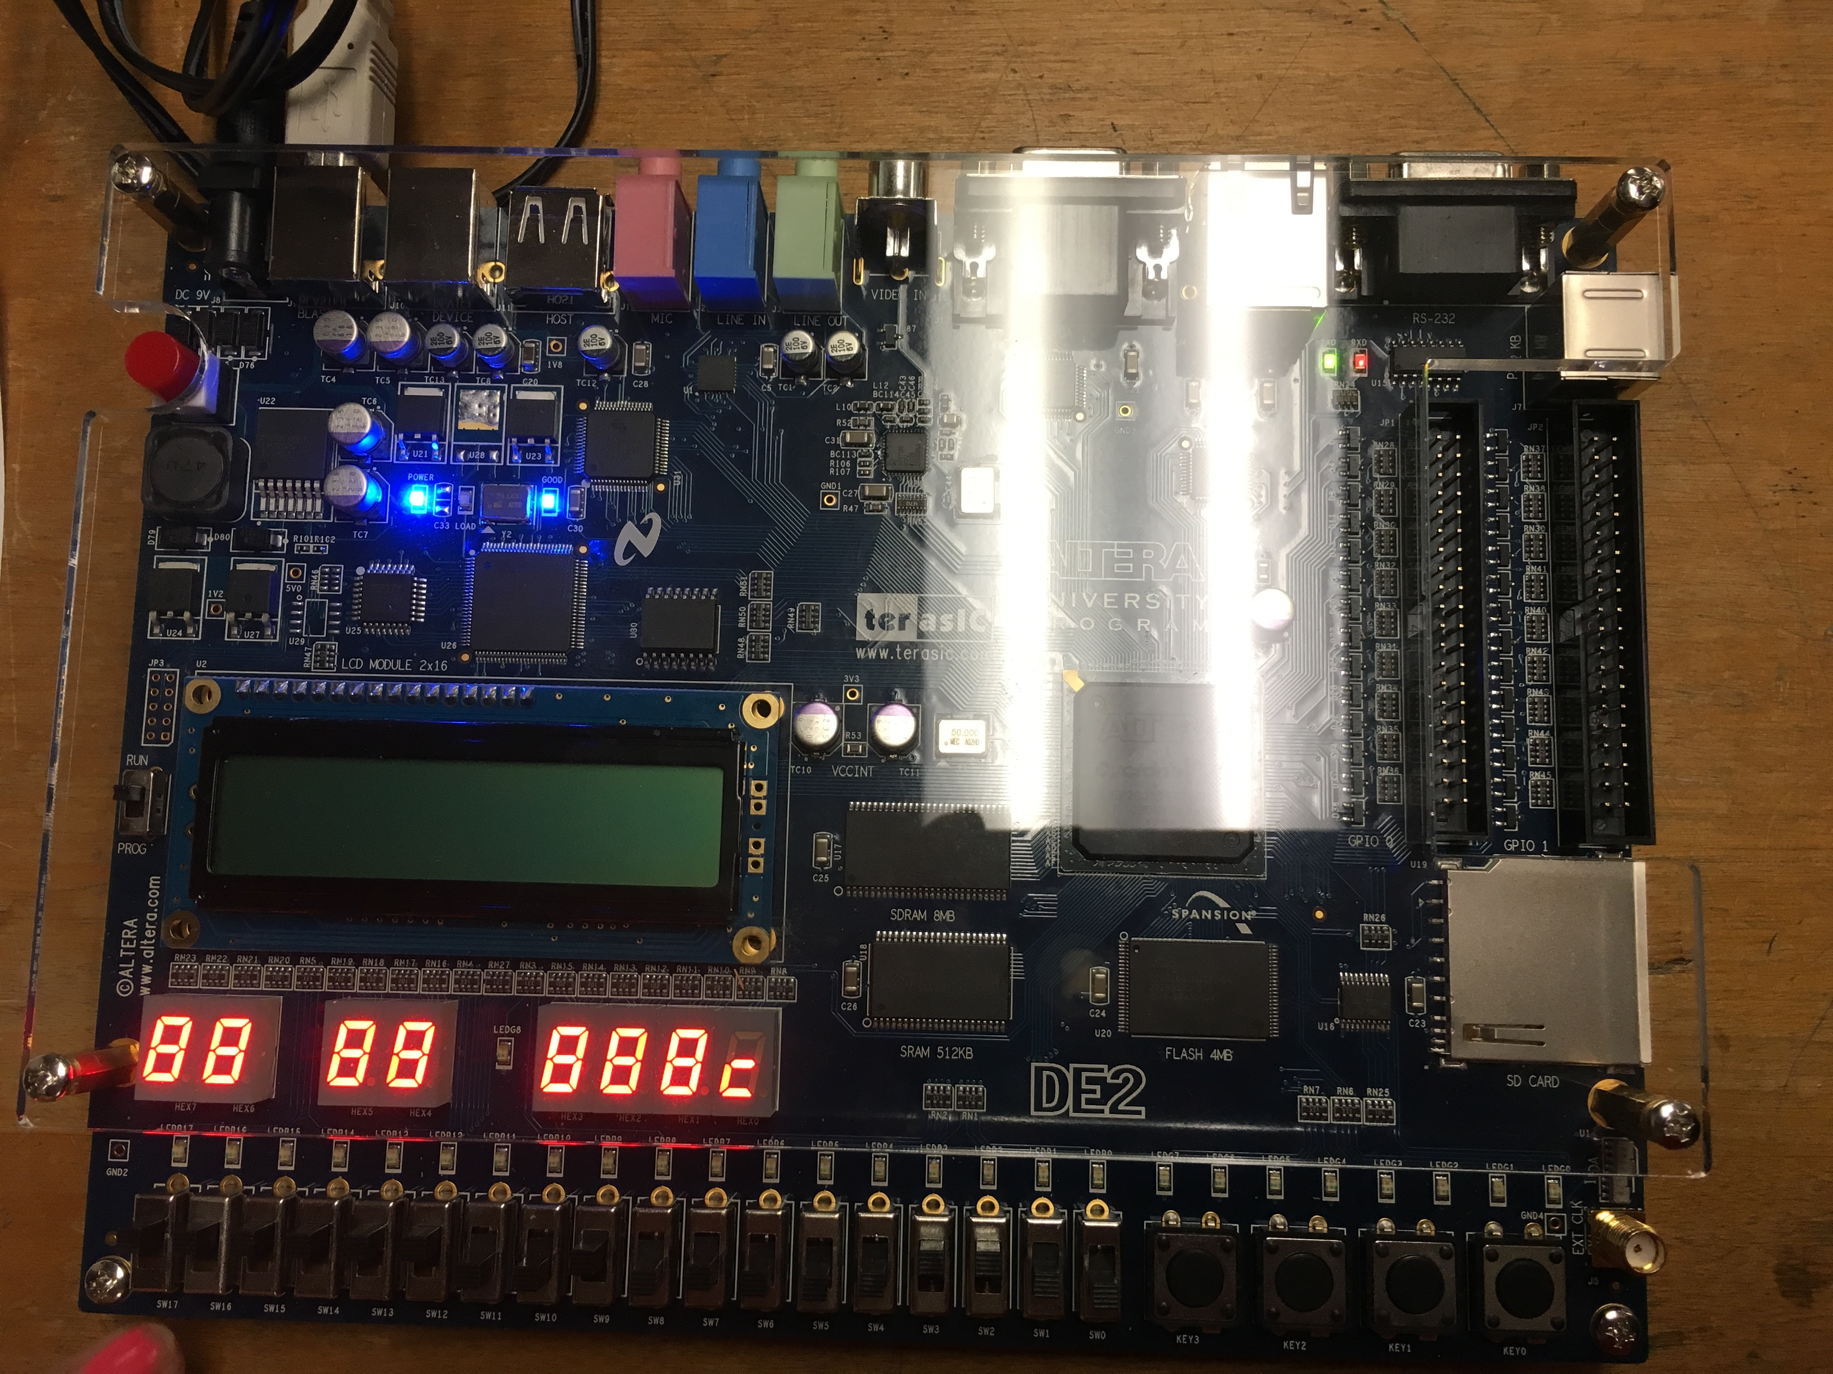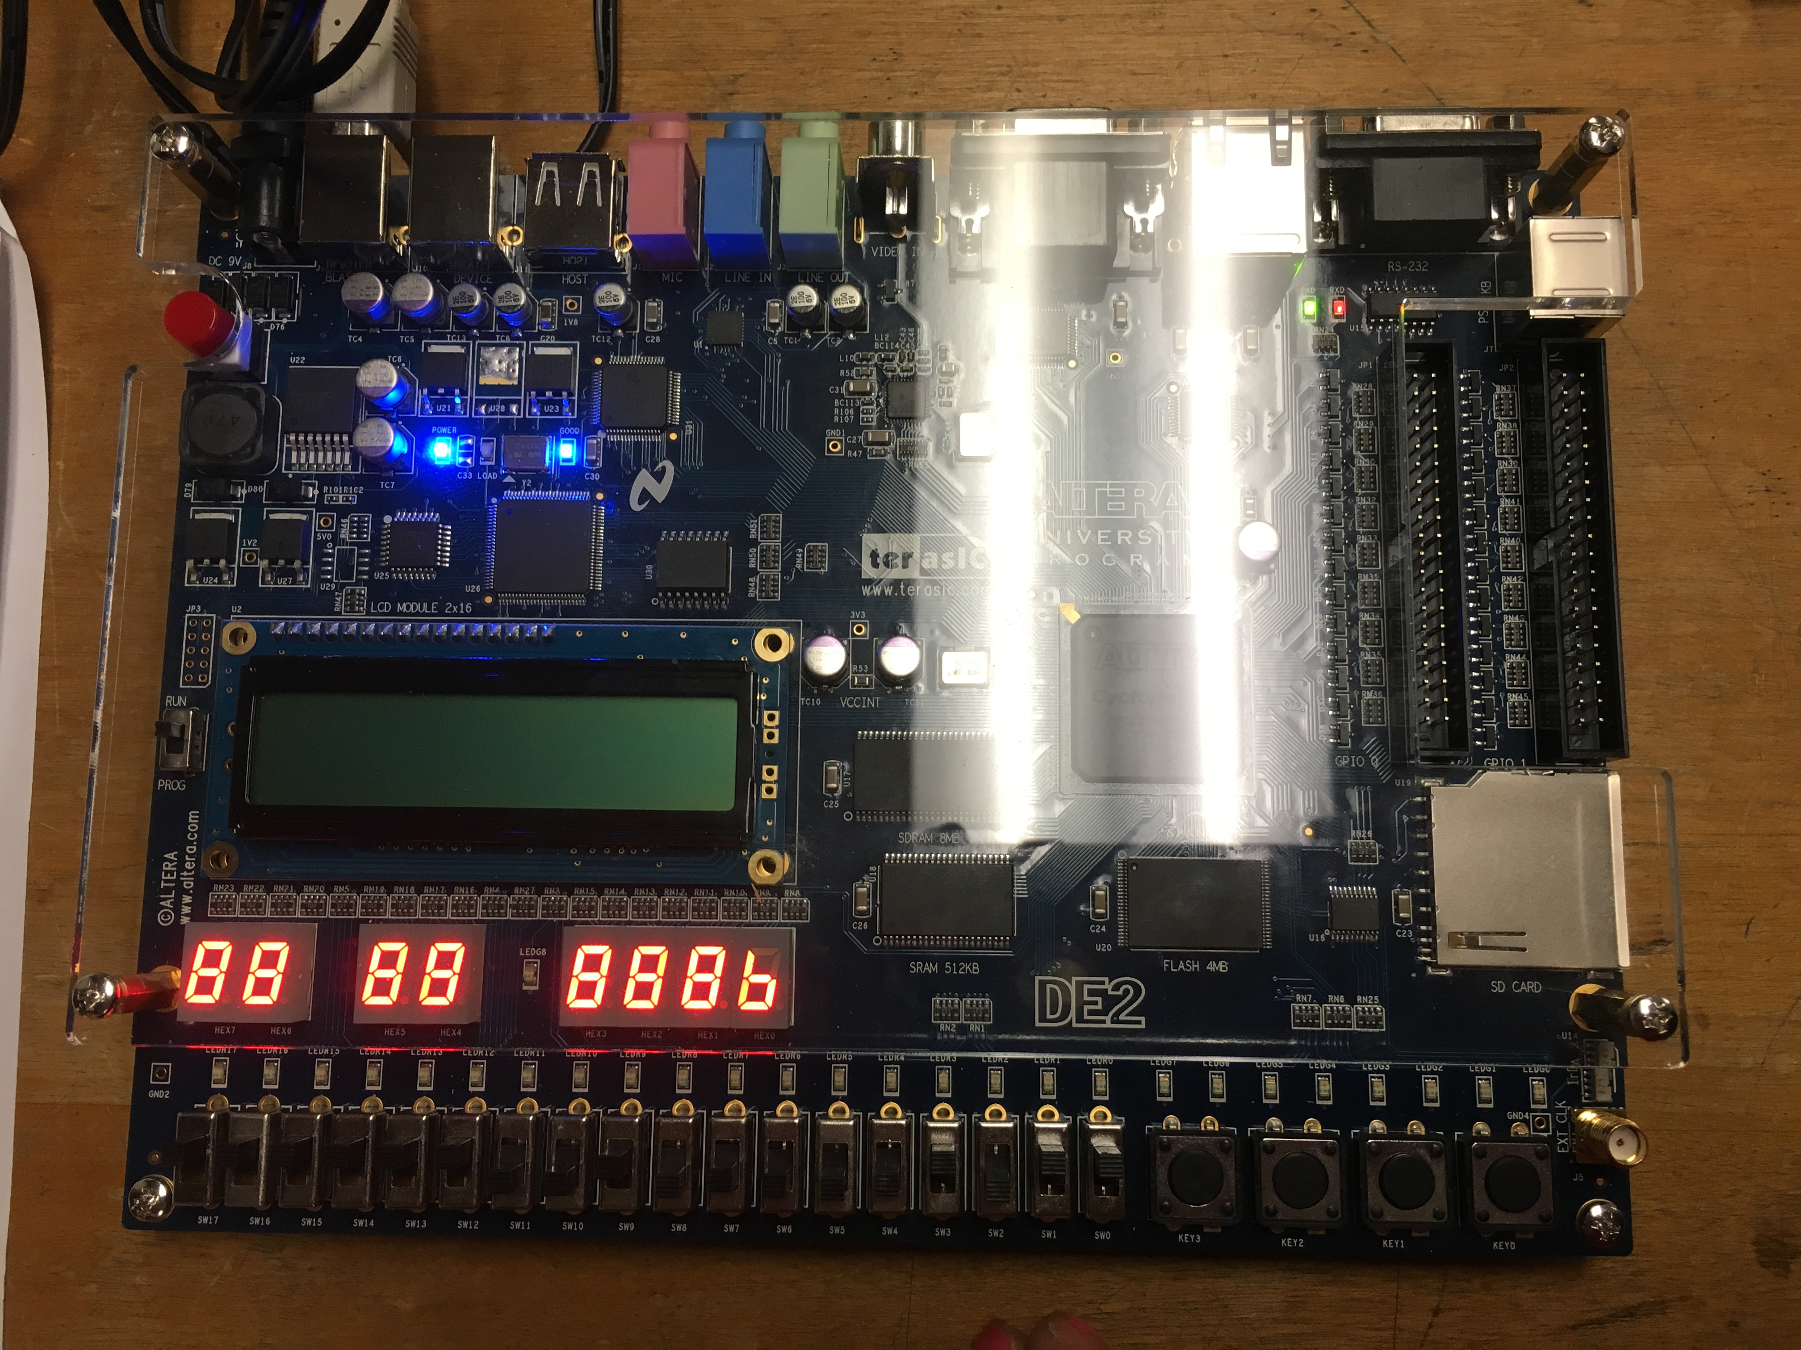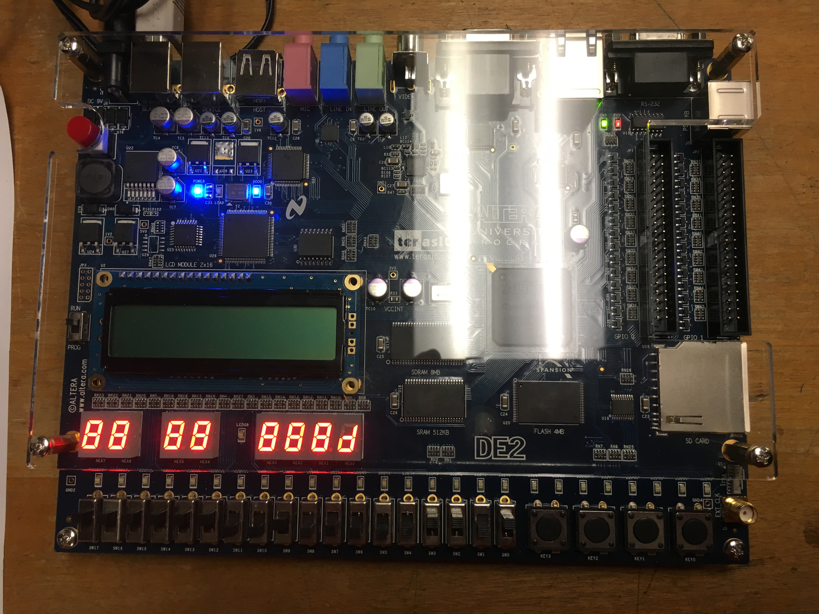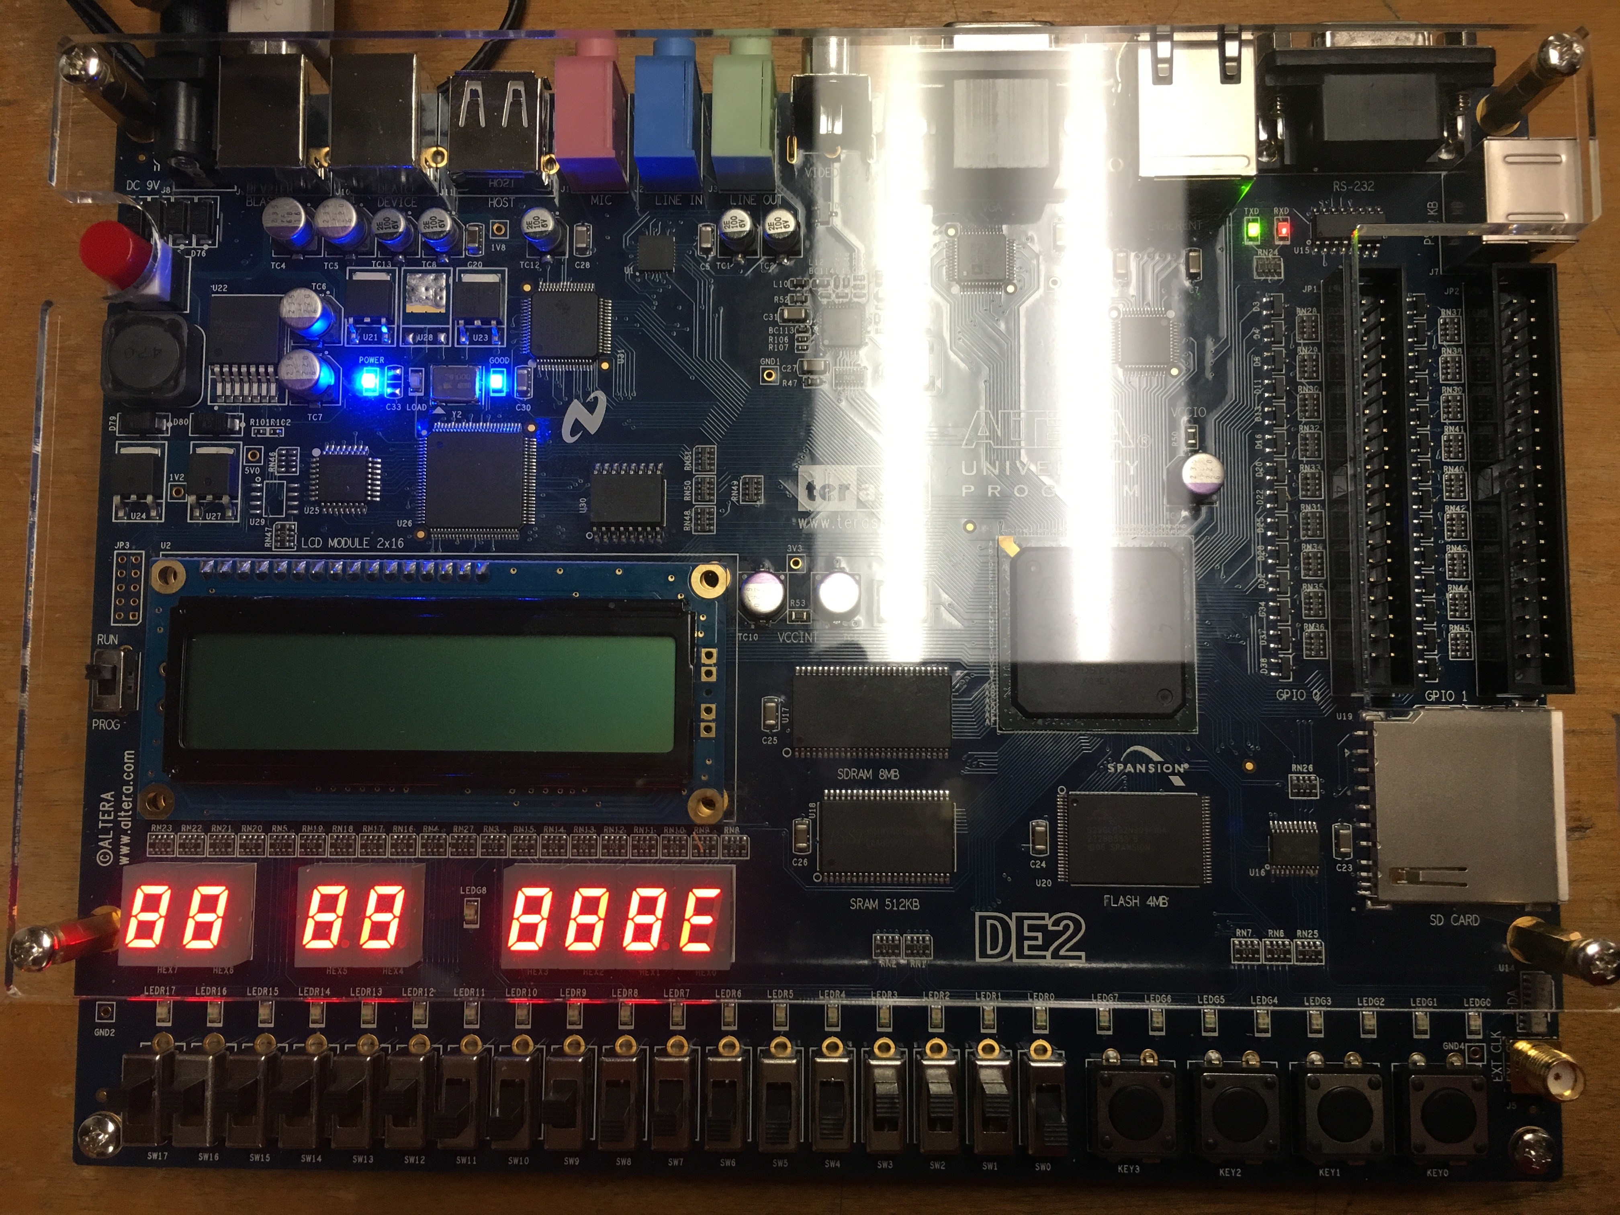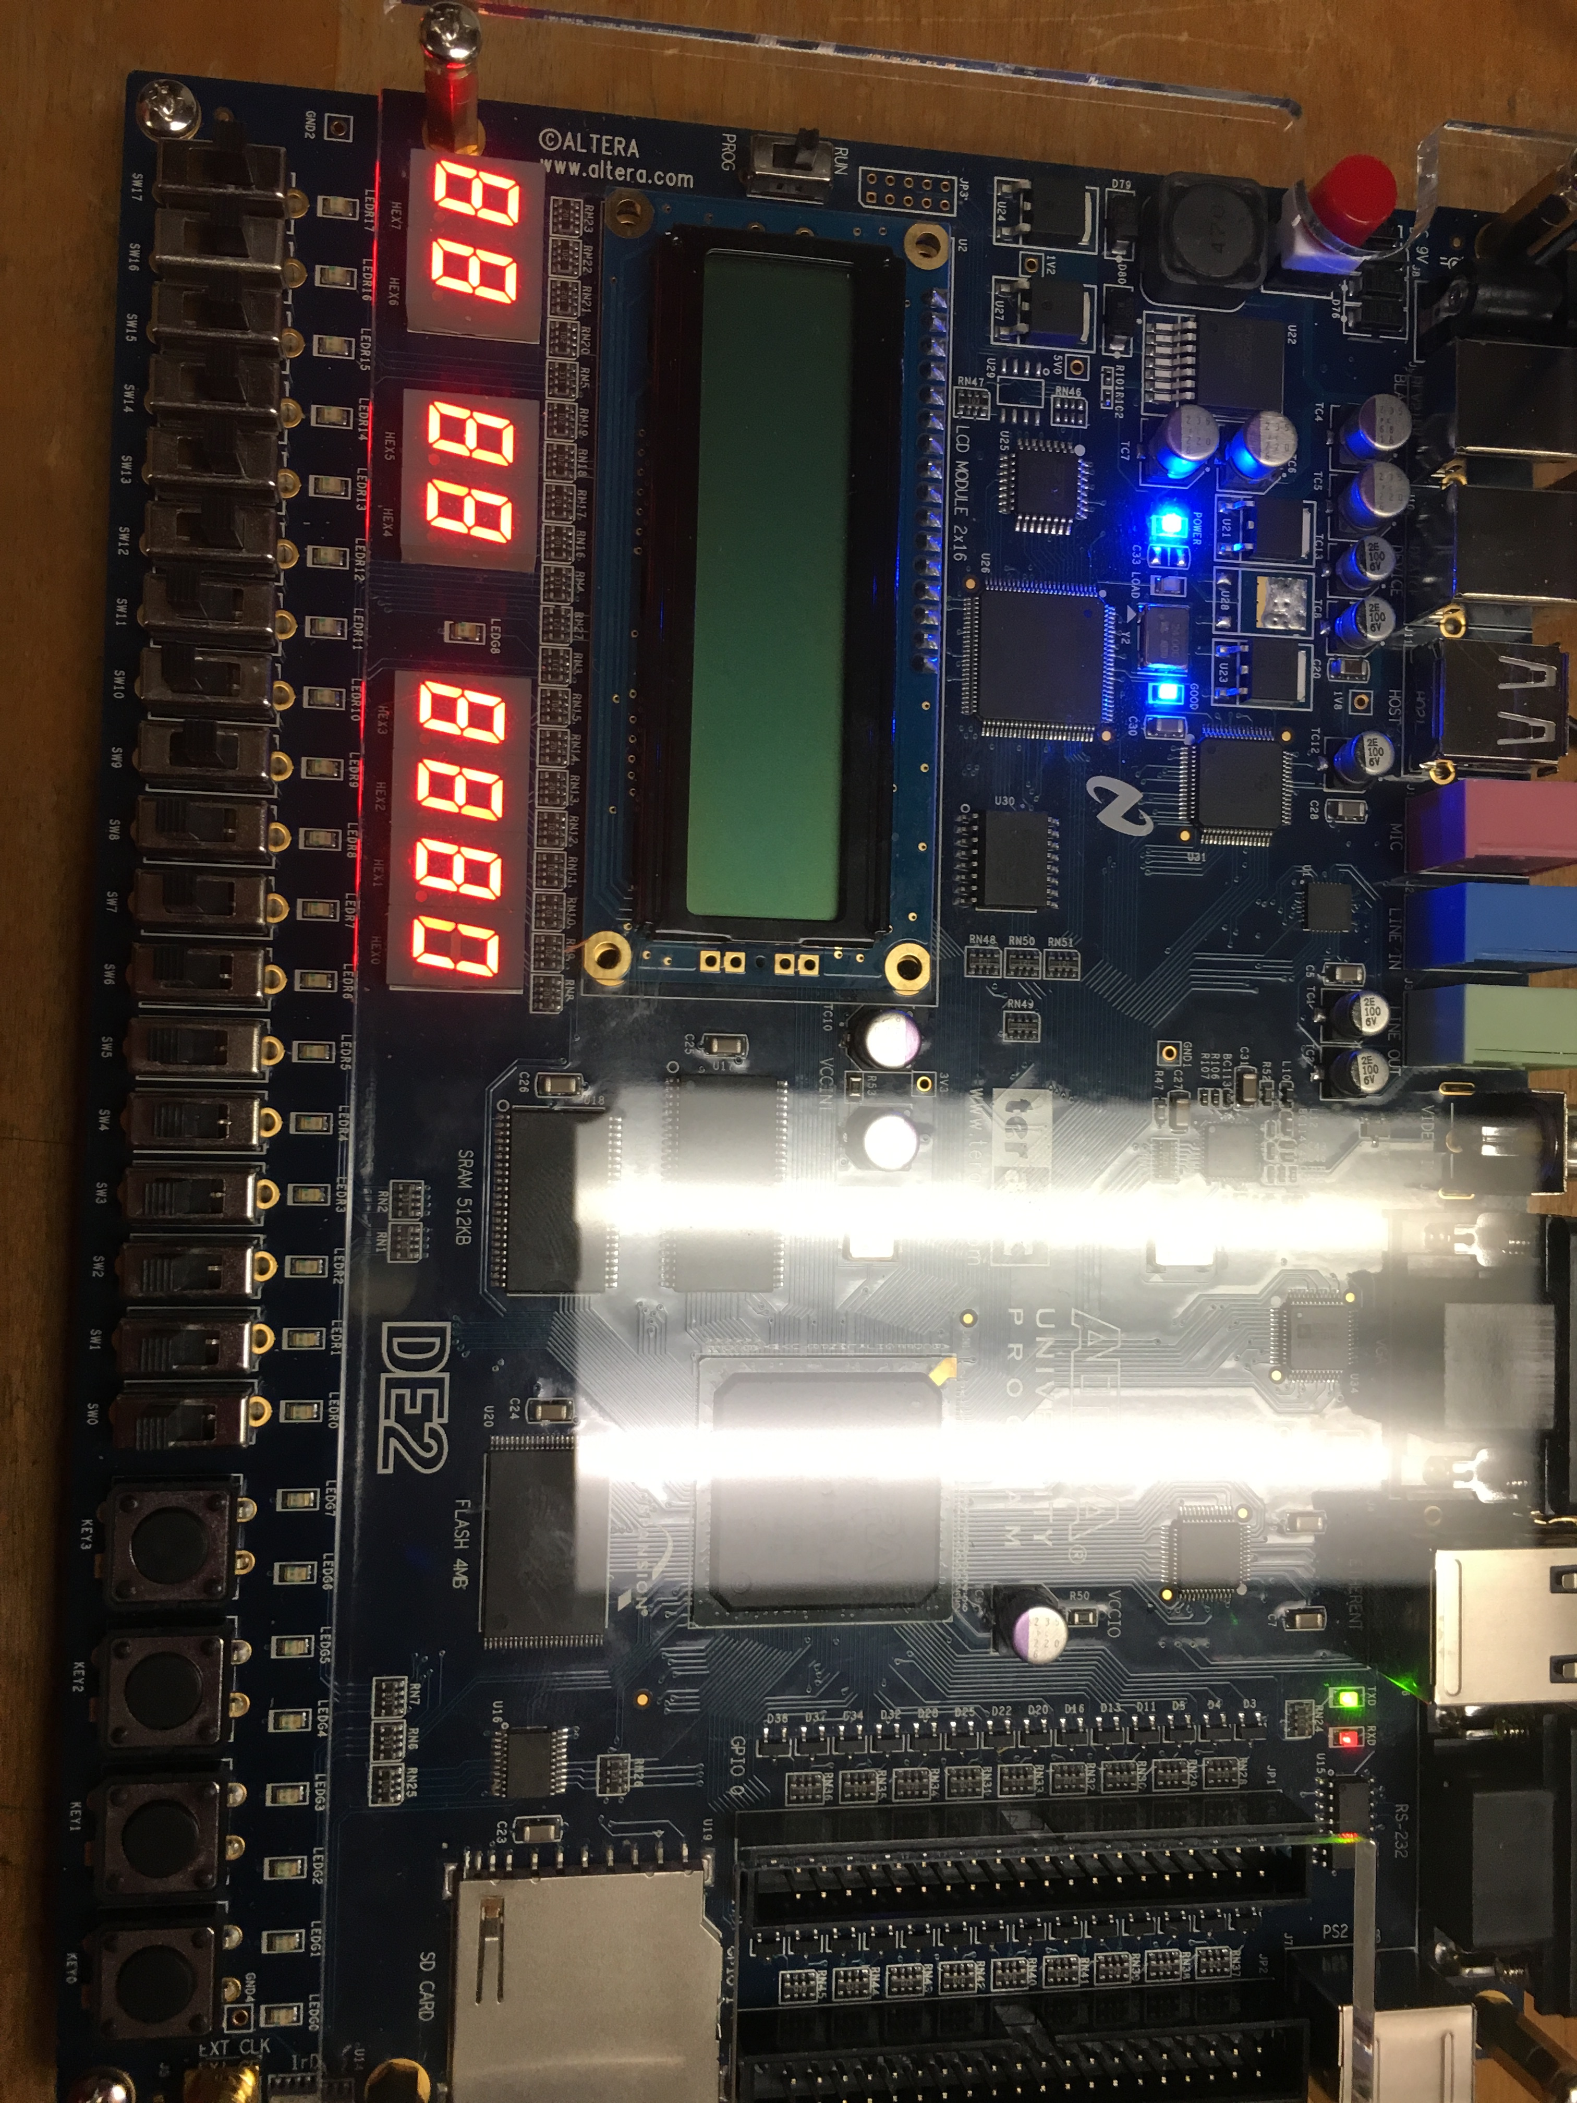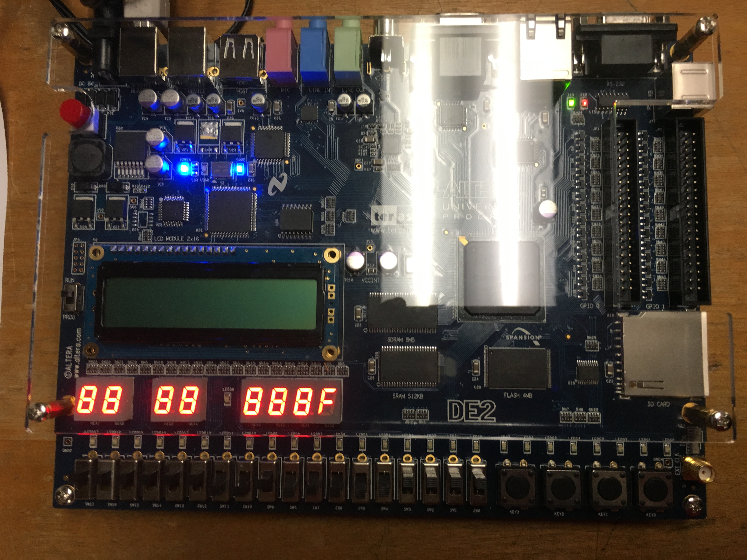

**Arnika Vishwakarma (@01367603)**